**TYBSc Zoology Sem VI course 16 General Pathology Practical**

**Melasma** also known as chloasma faciei, or the mask of pregnancy when present in pregnant women is a tan or dark skin discoloration. Although it can affect anyone, melasma is particularly common in pregnant women and those who are taking oral or contraceptives or hormone replacement therapy (HRT) medications.

The symptoms of melasma are dark, irregular well demarcated hyperpigmented macules to patches commonly found on the upper cheek, nose, lips, upper lip, and forehead. These patches often develop gradually over time. Melasma does not cause any other symptoms beyond the cosmetic discoloration. Melasma is also common in pre-menopausal women. It is thought to be enhanced by surges in certain hormones.

Melasma is thought to be the stimulation of [melanocytes](https://en.wikipedia.org/wiki/Melanocyte) (cells in the [epidermal layer](https://en.wikipedia.org/wiki/Epidermis_(skin)) of skin that produce a [pigment](https://en.wikipedia.org/wiki/Pigment,_biology) called [melanin](https://en.wikipedia.org/wiki/Melanin)) by the female sex hormones [estrogen](https://en.wikipedia.org/wiki/Estrogen) and [progesterone](https://en.wikipedia.org/wiki/Progesterone) to produce more [melanin](https://en.wikipedia.org/wiki/Melanin) pigments when the skin is exposed to sun. Women living in regions with intense sun exposure are particularly susceptible to developing this condition.

Genetic predisposition is also a major factor in determining whether someone will develop melasma.

The incidence of melasma also increases in patients with [thyroid disease](https://en.wikipedia.org/wiki/Thyroid_disease). It is thought that the overproduction of [melanocyte-stimulating hormone](https://en.wikipedia.org/wiki/Melanocyte-stimulating_hormone) (MSH) brought on by stress can cause outbreaks of this condition. Other rare causes of melasma include allergic reaction to medications and cosmetics.

Melasma is usually diagnosed visually or with assistance of a [Wood's lamp](https://en.wikipedia.org/wiki/Wood%27s_lamp), excess [melanin](https://en.wikipedia.org/wiki/Melanin) in the epidermis can be distinguished from that of the dermis.

Treatments are often ineffective as it comes back with continued exposure to the sun. Assessment by a dermatologist will help guide treatment. Treatments to hasten the fading of the discolored patches include application of certain acids and creams such a Topical depigmenting agents, [Tretinoin](https://en.wikipedia.org/wiki/Tretinoin) [acid](https://en.wikipedia.org/wiki/Acid) , [Azelaic acid](https://en.wikipedia.org/wiki/Azelaic_acid)  Tranexamic acid, Cysteamine hydrochloride (5%), Flutamide (1%), [Chemical peels](https://en.wikipedia.org/wiki/Chemical_peels), Microdermabrasion, Galvanic or ultrasound facials.

In all of these treatments the effects are gradual and a strict avoidance of sunlight is required. The use of broad-spectrum sunscreens with physical blockers, such as titanium dioxide and zinc dioxide is preferred over that with only chemical blockers. [Cosmetic camouflage](https://en.wikipedia.org/wiki/Cosmetic_camouflage) can also be used to hide melasma.

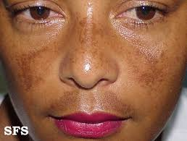

**Melasma**

**Vitiligo** is a long term [skin](https://en.wikipedia.org/wiki/Skin) condition characterized by patches of the skin [losing their pigment](https://en.wikipedia.org/wiki/Depigmentation). The patches of skin affected become white and usually have sharp margins. The hair from the skin may also become white. Inside the mouth and nose may also be involved. Typically both sides of the body are affected. Often the patches begin on areas of skin that are exposed to the sun. It is more noticeable in people with dark skin. Vitiligo may result in [psychological stress](https://en.wikipedia.org/wiki/Psychological_stress) and those affected may be [stigmatized](https://en.wikipedia.org/wiki/Stigmatized). The only sign of vitiligo is the presence of pale patchy areas of depigmented skin which tend to occur on the extremities. The patches are initially small, but often grow and change shape. They are most prominent on the face, hands and wrists. The loss of skin pigmentation is particularly noticeable around body orifices, such as the mouth, eyes [nostrils](https://en.wikipedia.org/wiki/Nostril), [genitalia](https://en.wikipedia.org/wiki/Genitalia) and [umbilicus](https://en.wikipedia.org/wiki/Navel). Patients who are [stigmatized](https://en.wikipedia.org/wiki/Stigmatization) for their condition may experience depression and similar [mood disorders](https://en.wikipedia.org/wiki/Mood_disorder).

Although multiple hypotheses have been suggested as potential triggers that cause vitiligo, studies strongly imply that changes in the immune system are responsible for the condition.

The cause is typically unknown. It is believed to be due to [genetic susceptibility](https://en.wikipedia.org/wiki/Genetic_susceptibility) that is triggered by an environmental factor such that an [autoimmune disease](https://en.wikipedia.org/wiki/Autoimmune_disease) occurs. This results in the destruction of [skin pigment cells](https://en.wikipedia.org/wiki/Melanocyte). Risk factors include a family history of the condition or other autoimmune diseases, it is not [contagious](https://en.wikipedia.org/wiki/Contagious_disease). Vitiligo is classified into two main types: segmental and non-segmental. Most cases are non-segmental, meaning they affect both sides; and these cases typically get worse with time. About 10% of cases are segmental, meaning they mostly involve one side of the body; and these cases do not typically worsen with time. Diagnosis can be confirmed by [tissue biopsy](https://en.wikipedia.org/wiki/Tissue_biopsy).

There is no known cure for vitiligo. For those with [light skin](https://en.wikipedia.org/wiki/Light_skin), [sunscreen](https://en.wikipedia.org/wiki/Sunscreen) and [makeup](https://en.wikipedia.org/wiki/Makeup) are all that is typically recommended. Other treatment options may include [steroid](https://en.wikipedia.org/wiki/Glucocorticoid) creams or [phototherapy](https://en.wikipedia.org/wiki/Phototherapy) to darken the light patches. Alternatively, efforts to lighten the unaffected skin, such as with [hydroquinone](https://en.wikipedia.org/wiki/Hydroquinone), may be tried. A number of surgical options are also available. A combination of treatments generally has better outcomes. [Counselling](https://en.wikipedia.org/wiki/Counselling) to provide emotional support may be useful.

Globally about 1% of people are affected by vitiligo.[ Some populations have rates as high as 2–3%. Males and females are equally affected. About half show the disorder before age 20 and most develop it before age 40. Vitiligo has been described since [ancient history](https://en.wikipedia.org/wiki/Ancient_history).

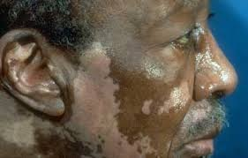

**Vitiligo**

**Psoriasis** is a long-lasting [autoimmune disease](https://en.wikipedia.org/wiki/Autoimmune_disease) which is characterized by patches of abnormal skin. These skin patches are typically [red](https://en.wikipedia.org/wiki/Erythema), itchy, and scaly. They may vary in severity from small and localized to complete body coverage.

There are five main types of psoriasis: plaque, [guttate](https://en.wikipedia.org/wiki/Guttate_psoriasis), [inverse](https://en.wikipedia.org/wiki/Inverse_psoriasis), pustular, and [erythrodermic](https://en.wikipedia.org/wiki/Psoriatic_erythroderma). Plaque psoriasis, also known as psoriasis vulgaris, makes up about 90% of cases. It typically presents with red patches with white scales on top. Areas of the body most commonly affected are the back of the forearms, shins, around the navel, and the scalp. [Fingernails](https://en.wikipedia.org/wiki/Nail_(anatomy)) and toenails are affected in most people at some point in time. This may include pits in the nails or changes in nail color.

Psoriasis is generally thought to be a [genetic disease](https://en.wikipedia.org/wiki/Genetic_disease) which is triggered by environmental factors. Symptoms often worsen during winter and with certain medications such as [beta blockers](https://en.wikipedia.org/wiki/Beta_blockers) or [NSAIDs](https://en.wikipedia.org/wiki/NSAIDs) (Non Steroidal Anti Inflammatrory Drugs). Infections and [psychological stress](https://en.wikipedia.org/wiki/Psychological_stress) may also play a role. Psoriasis is not [contagious](https://en.wikipedia.org/wiki/Contagious_disease). The underlying mechanism involves the [immune system](https://en.wikipedia.org/wiki/Immune_system) reacting to [skin cells](https://en.wikipedia.org/wiki/Keratinocyte). Diagnosis is typically based on the signs and symptoms.

There is no cure for psoriasis. However, various treatments can help control the symptomsThese treatments may include [steroid creams](https://en.wikipedia.org/wiki/Corticosteroid), [vitamin D3](https://en.wikipedia.org/wiki/Vitamin_D3) cream, [ultraviolet light](https://en.wikipedia.org/wiki/Ultraviolet_light), and [immune system suppressing medications](https://en.wikipedia.org/wiki/Immunosuppressive_drug) such as [methotrexate](https://en.wikipedia.org/wiki/Methotrexate).About 75% of cases can be managed with creams alone. The disease affects 2–4% of the population. Men and women are affected with equal frequency. The disease may begin at any age but usually starts in adulthood. 

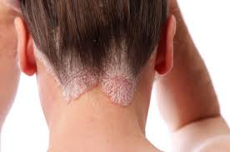

**Psoriasis**

**Bedsores**, also known as **pressure sores**, are localized damage to the skin and/or underlying tissue that usually occur over a [bony](https://en.wikipedia.org/wiki/Bone) prominence as a result of pressure, or pressure in combination with shear and/or friction. The most common sites are the skin overlying the  [sacrum](https://en.wikipedia.org/wiki/Sacrum),  [coccyx](https://en.wikipedia.org/wiki/Coccyx), [heels](https://en.wikipedia.org/wiki/Heel) or the [hips](https://en.wikipedia.org/wiki/Hip), but other sites such as the [elbows](https://en.wikipedia.org/wiki/Elbow), [knees](https://en.wikipedia.org/wiki/Knee), [ankles](https://en.wikipedia.org/wiki/Ankle), back of [shoulders](https://en.wikipedia.org/wiki/Shoulder), or the back of the [cranium](https://en.wikipedia.org/wiki/Cranium) can be affected.

Pressure ulcers occur due to pressure applied to [soft tissue](https://en.wikipedia.org/wiki/Soft_tissue) resulting in completely or partially obstructed [blood flow](https://en.wikipedia.org/wiki/Blood_flow) to the soft tissue. Shear is also a cause, as it can pull on blood vessels that feed the skin. Pressure ulcers most commonly develop in individuals who are not moving about, such as those being bedridden or confined to a wheelchair. It is widely believed that other factors can influence the tolerance of skin for pressure and shear, thereby increasing the risk of pressure ulcer development.

These factors are protein-calorie malnutrition, skin wetness caused by sweating or [incontinence](https://en.wikipedia.org/wiki/Urinary_incontinence), diseases that reduce blood flow to the skin, such as [arteriosclerosis](https://en.wikipedia.org/wiki/Arteriosclerosis), or diseases that reduce the sensation in the skin, such as [paralysis](https://en.wikipedia.org/wiki/Paralysis) or [neuropathy](https://en.wikipedia.org/wiki/Neuropathy). The [healing](https://en.wikipedia.org/wiki/Wound_healing) of pressure ulcers may be slowed by the age of the person, medical conditions (such as arteriosclerosis, [diabetes](https://en.wikipedia.org/wiki/Diabetes) or [infection](https://en.wikipedia.org/wiki/Infection)), smoking or medications such as [anti-inflammatory](https://en.wikipedia.org/wiki/Anti-inflammatory) drugs.

Although often prevented and treatable if detected early, pressure ulcers can be very difficult to prevent in critically ill people, [frail](https://en.wikipedia.org/wiki/Frailty_syndrome) elders, individuals with impaired mobility such as wheelchair users (especially where spinal injury is involved). [Primary prevention](https://en.wikipedia.org/wiki/Primary_prevention) is to redistribute pressure by regularly turning the person. The benefit of turning to avoid further sores is well documented since at least the 19th century. In addition to turning and re-positioning the person in the bed or wheelchair, eating a balanced diet with adequate protein and keeping the skin free from exposure to urine and stool is very important.

**The definitions of the four stages are as follows**.

* **Stage I**: Intact skin with redness of a localized area usually over a bony prominence. Stage I may be difficult to detect in individuals with dark skin tones.
* **Stage II**: Partial thickness loss of [dermis](https://en.wikipedia.org/wiki/Dermis) presenting as a shallow open ulcer with a red pink wound bed open/ruptured serum-filled blister.
* **Stage III**: Full thickness tissue loss. [Subcutaneous fat](https://en.wikipedia.org/wiki/Subcutaneous_fat) may be visible but bone, tendon or muscle are not exposed.
* **Stage IV**: Full thickness tissue loss with exposed [bone](https://en.wikipedia.org/wiki/Bone), [tendon](https://en.wikipedia.org/wiki/Tendon) or [muscle](https://en.wikipedia.org/wiki/Muscle). The depth of a stage IV pressure ulcer varies by anatomical location.

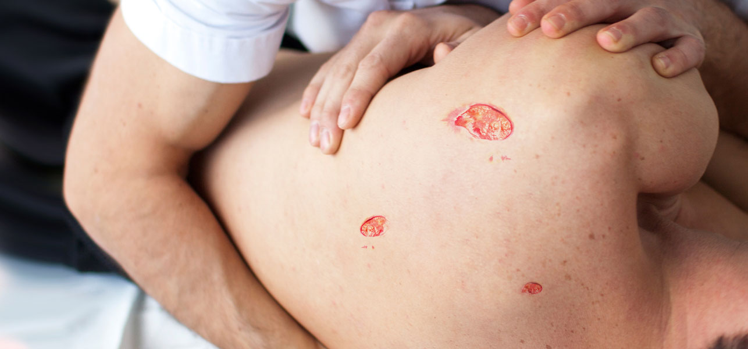

**Bedsores**

**Necrosis** or cell death, is a form of [cell injury](https://en.wikipedia.org/wiki/Cell_injury) which results in the premature [death](https://en.wikipedia.org/wiki/Death) of [cells](https://en.wikipedia.org/wiki/Cell_(biology)) in living [tissue](https://en.wikipedia.org/wiki/Tissue_(biology)) by [autolysis](https://en.wikipedia.org/wiki/Autolysis_(biology)).

Necrosis is caused by factors external to the cell or tissue, such as infection, toxins, or trauma which result in the unregulated digestion of cell components.

In contrast, [apoptosis](https://en.wikipedia.org/wiki/Apoptosis) is a naturally occurring programmed and targeted cause of cellular death.

While apoptosis often provides beneficial effects to the organism, necrosis is almost always detrimental and can be fatal.

Cellular death due to necrosis does not follow the apoptotic signal transduction pathway, but rather various receptors are activated, and result in the loss of [cell membrane](https://en.wikipedia.org/wiki/Cell_membrane) integrity and an uncontrolled release of products of cell death into the [extracellular space](https://en.wikipedia.org/wiki/Extracellular_space).

This initiates [inflammation in surrounding tissue response](https://en.wikipedia.org/wiki/Inflammatory_response) which attracts [leukocytes](https://en.wikipedia.org/wiki/Leukocytes) and nearby [phagocytes](https://en.wikipedia.org/wiki/Phagocyte) which eliminate the dead cells by [phagocytosis](https://en.wikipedia.org/wiki/Phagocytosis). However, microbial damaging substances released by leukocytes would create damage to surrounding tissues This excess damage inhibits the healing process. Thus, untreated necrosis results in a build-up of [decomposing](https://en.wikipedia.org/wiki/Decomposing) dead tissue and cell debris at or near the site of the cell death. A classic example is [gangrene](https://en.wikipedia.org/wiki/Gangrene). For this reason, it is often necessary to remove necrotic tissue [surgically](https://en.wikipedia.org/wiki/Surgical).

**Morphological patterns of necrosis can be classified following**:

1. [Coagulative necrosis](https://en.wikipedia.org/wiki/Coagulative_necrosis) is characterized by the formation of a gelatinous (gel-like) substance in dead tissues in which the cell structure of the tissue is maintained and can be observed by light microscopy. Coagulation occurs as a result of protein [denaturation](https://en.wikipedia.org/wiki/Denaturation_(biochemistry)), causing [albumin](https://en.wikipedia.org/wiki/Albumin) to transform into a firm and opaque state. This pattern of necrosis is typically seen in [hypoxic](https://en.wikipedia.org/wiki/Hypoxia_(medical)) (low-oxygen) environments, such as [infarction](https://en.wikipedia.org/wiki/Infarction). Coagulative necrosis occurs primarily in tissues such as the kidney, heart and adrenal glands
2. [Liquefactive necrosis](https://en.wikipedia.org/wiki/Liquefactive_necrosis), in contrast to coagulative necrosis, is characterized by the digestion of dead cells to form a viscous liquid mass. This is typical of bacterial, or sometimes fungal, infections. The necrotic liquid mass is frequently creamy yellow due to the presence of dead  [leukocytes](https://en.wikipedia.org/wiki/Leukocyte) and is commonly known as [pus](https://en.wikipedia.org/wiki/Pus). [Hypoxic](https://en.wikipedia.org/wiki/Hypoxia_(medical)) [infarcts](https://en.wikipedia.org/wiki/Infarction) in the brain presents as this type of necrosis.
3. [Gangrenous necrosis](https://en.wikipedia.org/wiki/Gangrenous_necrosis) can be considered a type of coagulative necrosis that resembles mummified tissue. It is characteristic of ischemia of lower limb and the gastrointestinal tracts.
4. [Caseous necrosis](https://en.wikipedia.org/wiki/Caseous_necrosis) can be considered a combination of coagulative and liquefactive necrosis, typically caused by [mycobacteria](https://en.wikipedia.org/wiki/Mycobacteria) (e.g. [tuberculosis](https://en.wikipedia.org/wiki/Tuberculosis)), fungi and some foreign substances. The necrotic tissue appears as white and [friable](https://en.wikipedia.org/wiki/Friable), like clumped cheese.

Necrosis may occur due to external or internal factors.

External factors may involve mechanical trauma (physical damage to the body which causes cellular breakdown), damage to blood vessels (which may disrupt blood supply to associated tissue), and  [ischemia](https://en.wikipedia.org/wiki/Ischemia). Thermal effects (extremely high or low temperature) can result in necrosis due to the disruption of cells.

In [frostbite](https://en.wikipedia.org/wiki/Frostbite), crystals form, increasing the pressure of remaining tissue and fluid causing the cells to burst. Under extreme conditions tissues and cells die through an unregulated process of destruction of membranes and cytosol.

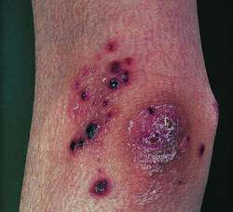

**Necrosis**

**Edema**, also spelled oedema, is an abnormal accumulation of fluid in the interstitium, located beneath the skin and in the cavities of the body, which can cause severe pain. Clinically, edema manifests as swelling. The amount of interstitial fluid is determined by the balance of fluid homeostasis; and the increased secretion of fluid into the interstitium.

Cutaneous edema is referred to as "pitting" when, after pressure is applied to a small area, the indentation persists after the release of the pressure. [Peripheral](https://en.wikipedia.org/wiki/Peripheral_edema) pitting edema, is the more common type, resulting from water retention. It can be caused by systemic diseases, pregnancy in some women, either directly or as a result of [heart failure](https://en.wikipedia.org/wiki/Heart_failure), or local conditions such as [varicose veins](https://en.wikipedia.org/wiki/Varicose_veins), [thrombophlebitis](https://en.wikipedia.org/wiki/Thrombophlebitis), insect bites, and [dermatitis](https://en.wikipedia.org/wiki/Dermatitis).

Edema caused by malnutrition defines [kwashiorkor](https://en.wikipedia.org/wiki/Kwashiorkor), an acute form of childhood protein-energy malnutrition characterized by edema, irritability, anorexia, ulcerating dermatoses, and an enlarged liver.

A rise in [hydrostatic pressure](https://en.wikipedia.org/wiki/Hydrostatic_pressure) occurs in [cardiac failure](https://en.wikipedia.org/wiki/Cardiac_failure). A fall in osmotic pressure occurs in [nephrotic syndrome](https://en.wikipedia.org/wiki/Nephrotic_syndrome) and [liver failure](https://en.wikipedia.org/wiki/Liver_failure).

Causes of edema which are generalized to the whole body can cause edema in multiple organs and peripherally. For example, severe heart failure can cause [pulmonary edema](https://en.wikipedia.org/wiki/Pulmonary_edema), pleural effusions, [ascites](https://en.wikipedia.org/wiki/Ascites)  and [peripheral edema](https://en.wikipedia.org/wiki/Peripheral_edema).

Edemas often occur during the late stages of pregnancy in some women. This is more common with those of a history of pulmonary problems or poor circulation also being intensified if arthritis is already present in that particular woman. Edemas that occur during pregnancy are usually found in the lower part of the leg, usually from the calf down.

**Edema can occur in specific organs such as organs**:

1. [Cerebral edema](https://en.wikipedia.org/wiki/Cerebral_edema) is extracellular fluid accumulation in the brain. It can occur in toxic or abnormal metabolic states and conditions such as systemic lupus or reduced oxygen at high altitudes. It causes drowsiness or loss of consciousness, leading to [brain herniation](https://en.wikipedia.org/wiki/Brain_herniation) and death.
2. [Pulmonary edema](https://en.wikipedia.org/wiki/Pulmonary_edema) occurs when the pressure in blood vessels in the lung is raised because of obstruction to the removal of blood via the pulmonary veins. This is usually due to failure of the left ventricle of the heart. It can also occur in altitude sickness or on inhalation of toxic chemicals. Pulmonary edema produces shortness of breath.
3. Edema may also be found in the cornea of the eye with glaucoma, severe conjunctivitis or keratitis or after surgery. Edema surrounding the eyes is called *periorbital edema* or [eye puffiness](https://en.wikipedia.org/wiki/Eye_puffiness). The periorbital tissues are most noticeably swollen immediately after waking, perhaps as a result of the gravitational redistribution of fluid in the horizontal position.
4. Common appearances of [cutaneous](https://en.wikipedia.org/wiki/Cutaneous) edema are observed with [mosquito](https://en.wikipedia.org/wiki/Mosquito) bites, [spider](https://en.wikipedia.org/wiki/Spider) bites, bee stings, and skin contact with certain plants such as chemicals.
5. Another cutaneous form of edema is [myxedema](https://en.wikipedia.org/wiki/Myxedema), which is caused by increased deposition of [connective tissue](https://en.wikipedia.org/wiki/Connective_tissue). In myxedema (and a variety of other rarer conditions) edema is caused by an increased tendency of the tissue to hold water within its extracellular space. In myxedema this is because of an increase in hydrophilic carbohydrate-rich molecules (perhaps mostly [hyaluronin](https://en.wikipedia.org/wiki/Hyaluronin)) deposited in the tissue matrix. Para Edema forms more easily in the elderly (sitting in chairs at home or on aeroplanes) and this is not well understood.
6. In [lymphedema](https://en.wikipedia.org/wiki/Lymphedema) abnormal removal of interstitial fluid is caused by failure of the [lymphatic system](https://en.wikipedia.org/wiki/Lymphatic_system). This may be due to obstruction from, for example, pressure from a [cancer](https://en.wikipedia.org/wiki/Cancer) or enlarged [lymph nodes](https://en.wikipedia.org/wiki/Lymph_nodes), destruction of lymph vessels by [radiotherapy](https://en.wikipedia.org/wiki/Radiotherapy), or infiltration of the lymphatics by infection (such as [elephantiasis](https://en.wikipedia.org/wiki/Podoconiosis)). It is most commonly due to a failure of the pumping action of muscles due to immobility, most strikingly in conditions such as multiple sclerosis, or paraplegia.

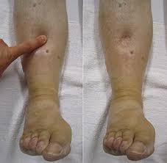 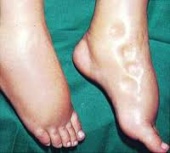

**Edema**

**Note:** 1. Information for Malaria, Filariasis, Leishmaniasis is not provided as they are old topics.

2. Teachers are at liberty to choose text and pictures of their choice.

 

**Melasma Vitiligo**

 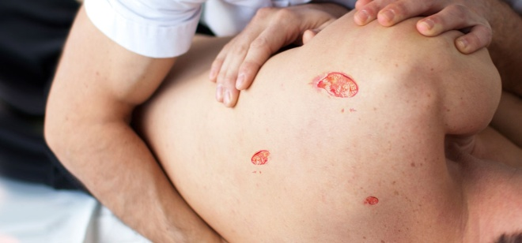

**Psoriasis Bedsores**

 

**Necrosis Edema**

